Tennyson High School
Athletic Department

To: WACC Principals, Athletic Directors, and Track & Field Coaches
From: Rachel Sagapolu, Athletic Director; Searcy Barnett and Gregory Morris
Re: 2026 WACC Non-Varsity Championship Meet

Site: Tennyson High School
Date: Wednesday, April 29, 2026
Parking: Please park in the parking lot located at the intersection of Whitman Street and Murray drive south of the school.
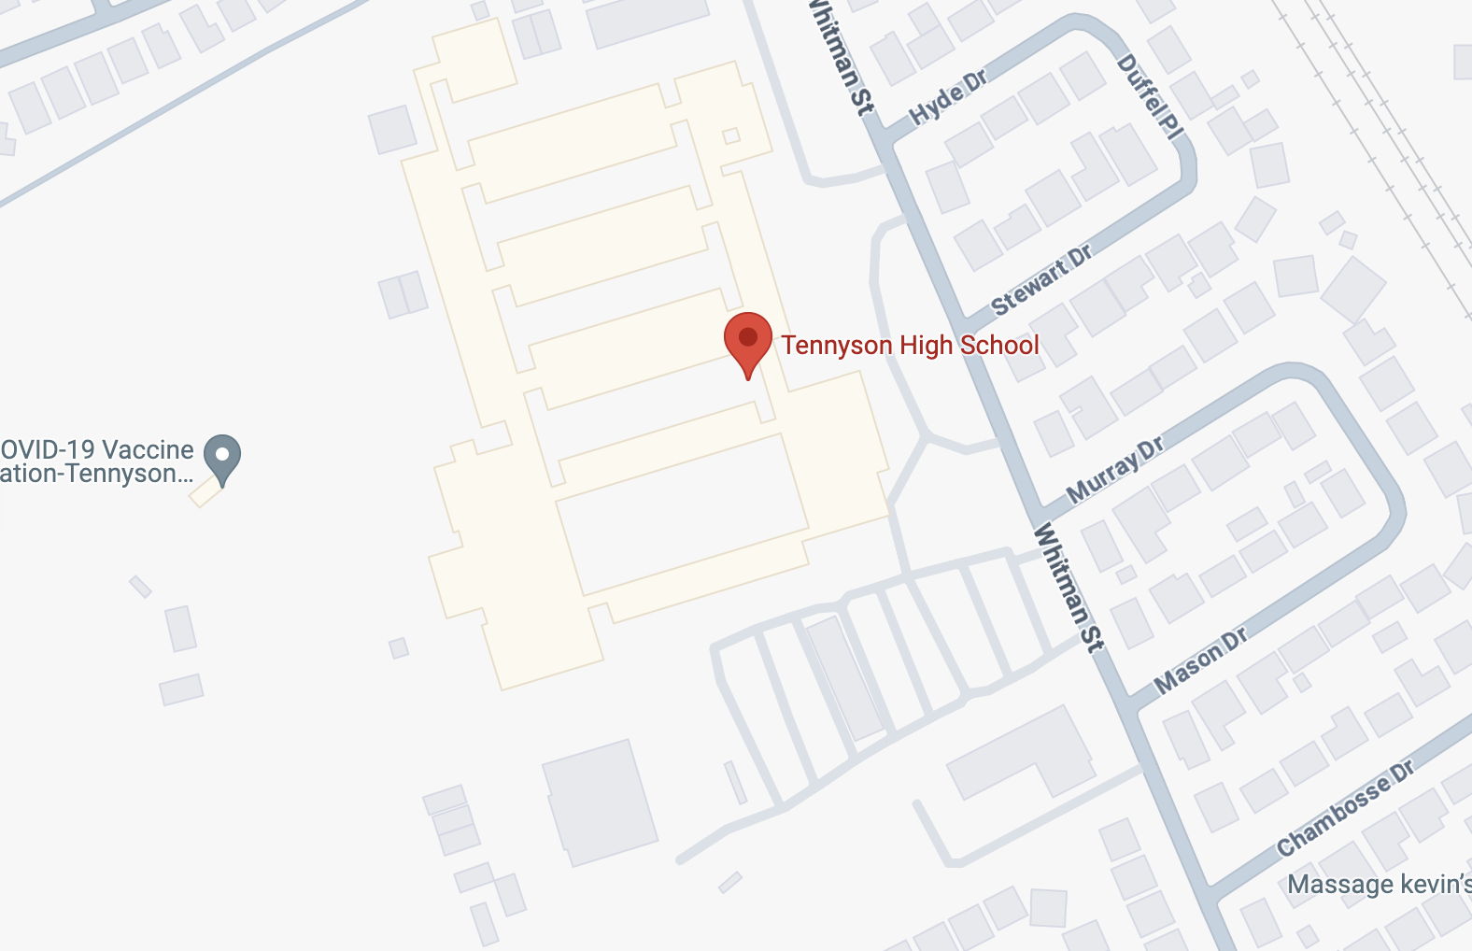
Format:
Coaches Meeting: 1:45 pm
Field Events Begin at: 2:00pm
Weigh-ins: 1:15pm
Track Events Begin at: 2:00pm
Meet Administration: Rachel Sagapolu and Veronica Estrada
Meet Director: Rachel Sagapolu and Searcy Barnett
Meet Referee: Searcy Barnett

Jury of Appeals: Meet Director and the two coaches with highest WACC seniority.

Announcer: Tennyson
Timer: AdkinsTrakWest
Initial Check in: San Lorenzo, Berkeley
Clerk/Reseeding: Hayward, Piedmont

Starting line: Castro Valley, Mt. Eden
Starter: Alameda, Bishop O’Dowd

Trainer: There will be a trainer at the event located in the far end zone
Meet Assignments: (Tennyson is Assignment Lead)
Relay Assignments
1st Exchange Zone: Bishop O’Dowd, Alameda, Arroyo, Berkeley,
2nd Exchange Zone: Castro Valley, Encinal, Hayward, Mt. Eden
3rd Exchange Zone: San Leandro, Piedmont, San Lorenzo, Tennyson

Event Assignments
Pole Vault: Piedmont, Castro Valley
High Jump: Castro Valley, Arroyo
Long Jump: San Leandro, Encinal, Alameda
Triple Jump: Encinal, San Leandro, Alameda
Shot Put: San Leandro, San Lorenzo
Discuss: Bishop O’Dowd, Arroyo
Hurdles: Castro Valley and Piedmont
Blocks: Castro Valley

Rules: The National Federation Track and Field Rules, The WACC Constitution and the Track
and Field Special Rules will govern the competition. Coaches, please remind to your athletes to
stay off the main Tennyson High School campus and within the prep area until the athletes’
race is called. Please stay within the track complex at all times.

Classification: Competition will be held in the boy’s non-varsity and girls’ non-varsity events.
Advancement to Finals: As there are no trials/finals performance marks determines final
placings.
Advancement to WACC Varsity Meet: The top three finishers in each event earn the right to
advance to the varsity track event.

Entry Process: Each school must enter athletes through www.atheltic.net by Wednesday, April 24th at 11:59pm. NO EXCEPTIONS. Please use the additional evening time to scratch any athletes from events so that reseeding of heats is kept to a minimum and all lanes are full.

Equipment: Each school must provide its own batons and spikes. All spikes must be 1⁄4 inch
pyramid spikes or shorter.

Team Implement Weigh-ins: Located at the Shot Put Ring. (See San Leandro, San Lorenzo)

Clean-up: We will allow 2 minutes prior to the final two events for each team to clean up their
area. Please remind your athletes and coaches to do so. NO FOOD/DRINK ON FIELD.

Team Warm-up Area: The warm-up area will be located on the grass field in front of the stadium. An area will be outlined. Due to the limited space and for safety reasons, no parents or spectators are allowed in this area.

Supervision/First Aid: All schools MUST provide their own supervision and first aid.
Supervision of your athletes is the responsibility of participating schools/coaches.
General Facility Rules:
1. Team tents may be set up in the stands IN THE BACK ROW ONLY.
2. Spectators are NOT ALLOWED on any of the fields or on the track AT ANY TIME.
3. Only athletes who are competing may be on the track or on the field.
4. Only athletes who are warming up may be in the designated warm up area.
5. Only sports drinks or water are allowed in competition or warm up areas..
6. Please keep all athletes off the main campus.

ORDER OF EVENTS
TRACK EVENTS
Start Time: 2:00pm (Girls then Boys - Fastest Heats First)
4x100meter Relay
1600meter Run
100/110meter Hurdles
400meter Dash
100meter Dash
800meter Run
300meter Hurdles
200meter Dash
3200meter Run
4x400meter Relay

FIELD EVENTS
Start Time Event
2:00pm Long Jump – Boys Pit #1 & Girls Pit #2 (Open Pit) Completed by 3:45pm
2:00pm Discus – Boys
2:00pm Shot Put – Girls
2:00pm High Jump -Boys
4:00pm Discus – Girls
4:00pm Shot Put – Boys
4:00pm High Jump -Girls
4:00pm Triple Jump – Boys & Girls Open Pit

